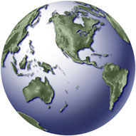 Creating a one-layer map

In this exercise you will:
- Get familiar with the basic concepts in desktop mapping and start learning some of the basic buttons for maneuvering through ArcMap.
- Learn how to bring a map into ArcMap.
- Learn how to use the symbology in ArcMap to change a map’s appearance, and how it can bring meaning to your information.

Data used:
Europe.shp

Stories

The simplest map we’re used to seeing is a map telling a single story.

Such a map might simply point out where a small town is located along a state’s panhandle. A map might trace a line where a proposed highway will run. A map might show the states in which presidential candidate won.

All of these are examples of a single layer of information. A point for a town. A line for a road. An area for a vote winner. These may sound simple, but it is important to do a single map before doing more complex work with multiple layers of information.

When Ramona Smith was covering the environment for the Philadelphia Daily News, she wanted to see how well the city’s recycling program was doing. So she got the data. The city kept track of how much was being recycled, sanitation district by sanitation district. By mapping out these districts, she was able to clearly see which neighborhoods were doing the most. And the least.

When J.J. Thompson was a graduate student at the University of North Carolina, she was curious: Where are the biggest income gaps? She compressed census data into a handy index (more later on the details of that index) and the result was she could see where the widest margins existed between the rich and poor in the state.

When The Washington Post’s Dan Keating was exploring where high tech businesses were emerging, he plotted Dun and Bradstreet data around the nation’s capital, and was able to see where the corridor was developing.

In all three cases, a single map told the story. A reader could look at these maps and know whether they lived in a community that recycled the most, or had the biggest gap between rich and poor, or whether new industry really was moving into their area.

The following sections explain how how to put together a single layer map in ArcMap. More complex analysis with multiple maps will come later.

About the tools

A lot of what makes up a mapping program is familiar ground to those who’ve done basic computer-assisted reporting. Mapping programs still use data stored in tables. They may let you point-and-click your way through a question, but the language running behind those mouse moves is still database query language or SQL. Mapping programs go several steps further and allow you to link data to maps, and to slice and dice data based on where the data fits on the globe.

But in addition to the data, you’re working with geography. Geography comes in several different forms. Outlined geographies such as counties or census tracts are known as polygons, streets, rivers and railroad tracts are lines and cities or events may be symbolized by points. As this book progresses, you’ll learn how to work with each of these types of geography.

Getting started: Bringing maps into ArcMap

ArcMap lets you set aside a work area for what you want to do. This work space is called a map document. It’s similar to the way a database works in Access and a project works in the latest versions of FoxPro. In map document, you can store tables and a whole lot more. The project also serves as a traffic cop, keeping track of the different places in your computer where you store the various maps and databases within your project.

We’re about to start a brand-new map document. We’re going to work with just one map, to get familiar with how the program works. But just because we’re working with only one map, don’t think there isn’t potential to find a story.

Let’s begin by bringing a map into ArcMap.
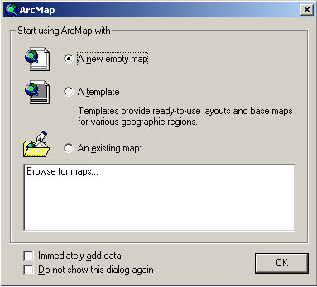
When you start ArcMap, it will ask you if you want to make a new map or use an old map. Choose “a new empty map”:

You'll get an empty window that is just waiting to be filled with a map. To add a map, click the ADD DATA button:

Go to the directory specified by your instructor and choose EUROPE.SHP. (SHP stands for shape file.) ArcMap can read layer files as well as ArcView files called “shape” (shp) files.

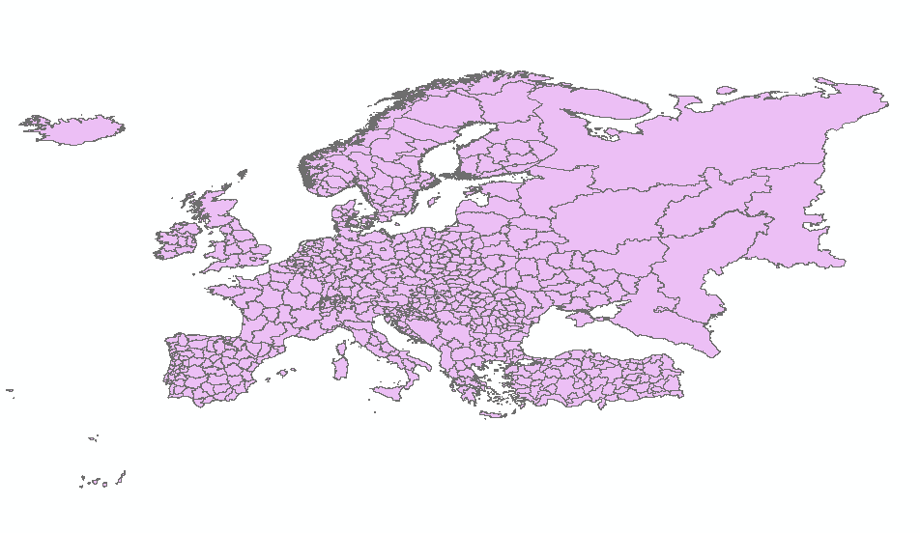

Right now the map is set so the entire map is the same color. It also is in the “full extent” zoom. Let’s zoom into just the main continent by clicking on the zoom tool.
With this tool, you can click and draw a box around the main land area.
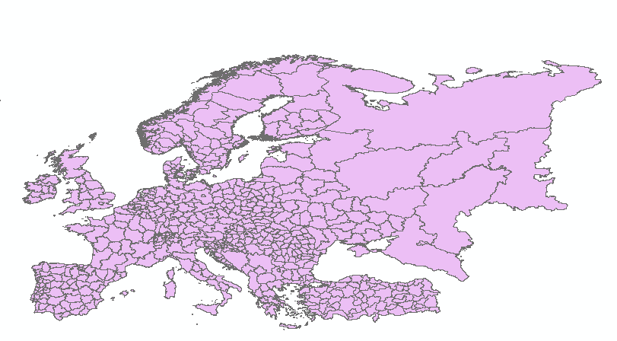

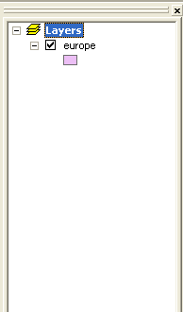
Let’s talk a little bit more about what you see on your screen. On the left is the table of contents – that tells you what data you have open.

Along the bottom, a tab lets you switch between your display and source. The source tells you where you are getting the data for the map.
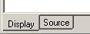

Behind the pretty pictures in any GIS program is a database. Right now, we're using data that comes with ArcMap and is already attached to this map. Let's look at one record in the data behind this map.

Click the IDENTIFY icon: You’ll see the Identify Results window pop up. As you click any county on the map, you'll get a window that tells you all the fields in this file. In other words, you’re getting a peek at one record in the counties database.

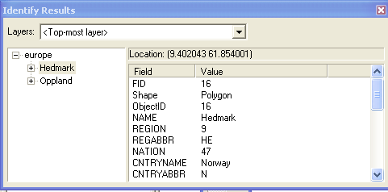
Scroll through the window and look at all the data you have. You can leave this window open and click on another county and it will switch to that county's record.

This is great, if you just want the information for one state, but what if you want to see the whole table? To see the whole table at once, close the identify window and RIGHT CLICK on the COUNTIES layer in the table of contents and choose OPEN ATTRIBUTE TABLE. You’ll see the sort of thing you’re used to if you use Access or Foxpro – rows and columns of data.

Spend a couple of minutes looking at the data. Looking through the data, we might want to create a thematic map based on some of the data.

Click on the far left of any record. Notice how it highlights the row. That’s one method of SELECTING information in your data. When you close the table, you’ll see that the county you selected is highlighted on the map. The map goes both ways. Choose the select tool. It looks like this: and click on a county. There’s another way to select. We’ll get to that later.

But first, it might be a good idea to save our map document. Close the attribute table.

Saving your map: FILE | SAVE AS and give your file a name. Keep in mind, ArcMap is really just saving an index of where all your information is, not all the information used in the map. So if you move stuff around on your computer, ArcMap will be used.

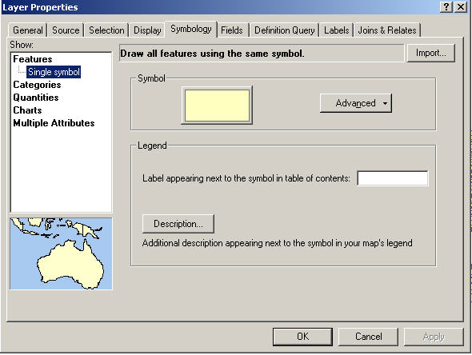
To do that, double-click on the EUROPE layer in the table of contents. Make sure the SYMBOLOGY tab is selected at the top.

Right now the map is using SINGLE SYMBOL symbology. Another type of map we might want to choose is CATEGORIES.

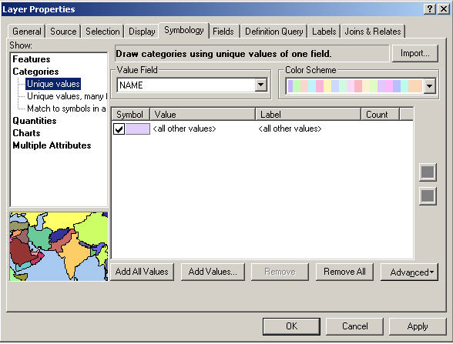
Using this symbology, every change in a value gets its only symbol, or color. Let’s say that we want each state to be a different color. In the box labeled VALUE FIELD, choose STATE_NAME. Then click ADD ALL VALUES at the bottom. Then click APPLY then OK.

The legend type is UNIQUE VALUE that means that every change in the VALUES_FIELD (in this case STATE_NAME) gets a unique value.

This map is interesting, but it really doesn’t give us any information. You may have noticed that the file contains demographic data. Go back to the layer properties window and choose QUANTITIES.

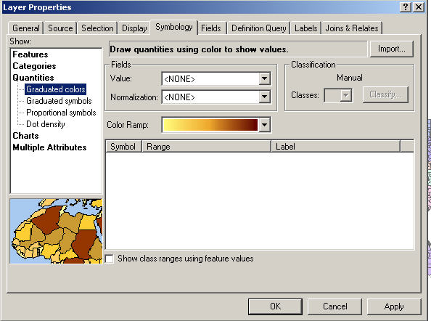

Choose GRADUATED COLORS, then under FIELDS choose the VALUE called PER_HH, which is persons per household.

ArcMap automatically assigns ranges and colors. You can change the color "ramp" to a variety of things. Take a few minutes to check out the various color groups.

Next, click APPLY in the lower right corner and OK and close the legend properties window. Your map shading will change. I think five colors is too confusing, so let's go back to the legend editor and switch the number of categories to three. To do that, under CLASSIFICATION, choose NUMBER and change it to 3. Click APPLY then OK.

Ugh, not only does create a weird map, the breaks are not easy for readers to understand. Let's create our own breaks so that the map makes more sense. Go back to the layer properties window. To change the classification, click the CLASSIFY button. And although this window looks like the cockpit of a jet, it has some very helpful information. It graphs the data so we can see the distribution. (Wow! Look at that nice normal curve.) and it summarizes our data.

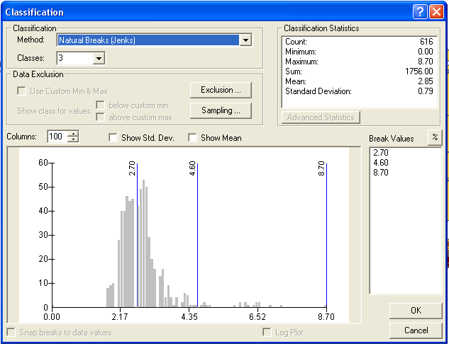
Click on the down arrow next to NATURAL BREAKS (JENKS). You’ll see that there are several types of distributions we could use for our data.

Natural Breaks: This is based on analysis ArcMap does to try to figure out where the data naturally breaks – or where big jumps occur in the data.
Equal interval: Each break will be an equal distance apart (10, 20, 30, …)
Quantile: This breaks the data so the same number of counties would be in each category.
Manual: This lets us pick the breaks. Most journalists use this because even categories are easier for readers to understand. Try a quantile map with four categories (quartiles).

Next, let’s do a MANUAL map so we can make the categories easy to understand. To use this, you must first pick the number of classes you want. Then, you can set the breaks by either typing them in the BREAK VALUES box or by moving the lines on the graph. Let’s type them in: 2.5 and 4.0. The top value will default to the highest value, in this case 8.7.

You can type in the values that you want for the range and edit the labels.

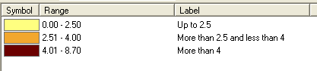

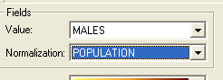
Using persons per household it was easy to just map the median value, but what if we wanted to map a particular race category. Would it make sense to just map the number of men or women? When you work with that data, you always need to base it on population. That’s where the NORMALIZE function comes in. For your value field choose MALES, then we need to NORMALIZE it to the population. In the NORMALIZATION drop-down menu, choose POPULATION.

Click APPLY and OK. Play around with some possible MANUAL breaks and see if you can come up with a better map.

Let’s learn some other handy tools. There are a couple quick ways to zoom in and out. Here is a list. Play with them a bit to get an idea how they work.

This lets you zoom in. Each time you click it, your map gets bigger.

This is its doppleganger. Zoom out each time you click it. And your map gets smaller.

Click this and the mouse cursor changes into a magnifying glass to zoom in. Just click and drag a box around the area you want to see close up.

This is its contrary sibling, the demagnifying glass. Just click and drag a box around the area you want to see reduced.

This hand lets us move the map around. Just click and drag the map.

Play around with these to get more familiar with how they work.

